ACT Legal Assistance Action Plan 2023‑2025
Appendix C to the ACT Legal Assistance Sector Strategy
In collaboration with

Legal Assistance Action Plan 2023-2025
The Legal Assistance Action Plan (the Action Plan) 2023-25 sits under the ACT Legal Assistance Strategy (the Strategy) and aims to provide an implementation plan for the Strategy. The Action Plan will enable the ACT Government and the ACT legal sector (the sector) to work toward strengthening sector capacity and sustainability, with a greater focus on wellbeing and access to justice for vulnerable people.
The Sector is committed to being responsive to community needs. For this reason, if there are significant changes in the sector landscape in this Strategy period, there may be a need for the Sector to adjust its initiatives and/or the implementation planning, while maintaining strong alignment to the Sector’s vision, priority outcomes and strategic directions. Any adjustments would be considered in collaboration across the Sector, and with the relevant approvals under the NLAP.

Legal Assistance Sector Partner Organisations

The key audience for this work is the organisations which make up the ACT Legal Assistance sector (the Partner organisations), the ACT Justice and Community Safety Directorate (JACS) and the ACT Attorney-General (together, the Sector) and broader justice stakeholders, such as the ACT Bar Association and ACT Law Society, ACT Courts and Tribunal and the Commonwealth Attorney-General’s Department.
The Partner organisations play a significant role in delivering legal assistance to the people and communities in the ACT, particularly to those experiencing disadvantage. There are four community legal centres in the ACT, one Legal Aid Commission and one Aboriginal and Torres Strait Islander Legal Service. The Partner organisations and other key stakeholders will play a critical role in delivering the initiatives of the Action Plan. They are:
Table 1: Legal Assistance Sector Partner Organisations
Partner organisation | Role in the sector
Legal Aid ACT | The Legal Aid Commission (Commission) helps people who live in the ACT or who are involved in proceedings in ACT courts and tribunals, and who are in need of legal advice or assistance but who are unable to access private legal services. The Commission’s clients are disadvantaged relative to the general population, often as a result of disability, illness, youth, old age, homelessness, language and cultural barriers, or financial difficulties.  The Commission seeks to improve vulnerable and disadvantaged people’s access to the justice system by providing a range of legal services through in-house legal and paralegal staff, and lawyers in private practice. The Commission’s services are wide-ranging and include the provision of:  - Information and referral services  - Legal advice and assistance  - Advocacy  - Duty lawyer services  - Grants of legal assistance and representation in Courts and Tribunals  - Dispute resolution services  - Community Legal Education programs  - Submissions on issues of law reform.
Canberra Community Law | Canberra Community Law (CCL) is an independent community legal centre. CCL are the only free legal service in the ACT specialising in public housing, Centrelink, disability discrimination, race discrimination and homelessness law. CCL’s legal team collaborates with CCL’s Social Worker and Disability Justice Liaison Officer to provide additional trauma informed support to people who face multiple barriers to resolving their issues.  CCL has been part of the Canberra community for over 35 years. During this time, CCL have responded to the changing and increasing needs of people in the ACT with trauma-informed and culturally responsive legal services. CCL has a demonstrated history of managing service delivery in the community legal sector, establishing well-designed services which addresses gaps in legal service delivery, and effectively supports the most vulnerable people in the ACT.  CCL pioneered the development of the Socio-Legal Practice (SLP) model in the ACT through establishing the SLP clinic. CCL’s other ground-breaking programs include Street Law and Dhurrawang Aboriginal Human Rights Program. CCL is governed by a voluntary community-based board of people from academic, community sector and the private legal profession.
Aboriginal Legal Service (NSW/ACT) Limited | The Aboriginal Legal Service (NSW/ACT) Limited (ALS) is a proud Aboriginal community-controlled organisation that provides legal services to eligible Aboriginal and Torres Strait Islander adults and children in the ACT.  The ALS currently undertakes legal work (duty, representation and minor assistance) in criminal law, and is expanding to offer services in care and protection and family violence. The ALS also delivers criminal law related wrap-around support programs and contributes to law reform and legal policy through submissions and fierce advocacy.
Women’s Legal Centre ACT | The Women’s Legal Centre improves the lives of women in Canberra through specialist legal representation, support and advocacy. It provides high quality legal services and maintains a holistic legal practice including multi-disciplinary and trauma-informed services that are designed to respond to legal issues that disproportionately affect women.  The Women Legal Centre operates a range of specialist services. The Mulleun Mura program strengthens Aboriginal and Torres Strait Islander culture and communities by supporting women and families to stay connected and stay safe. The Women’s Legal Centre also works in partnership with the Calvary Public Hospital Bruce and Child and Family Centres to deliver essential legal assistance to women affected by domestic and family violence. Its team of lawyers work together with a team of social workers and an Aboriginal Case Manager to better support clients and improve their experience of the legal system.  The Women’s Legal Centre understand the legal issues facing women and systemic gender inequality. It provides expert advice to government, community and other stakeholders, leveraging on its expertise and experiences of its clients to inform better law and policy responses for women.
Care Inc | Care Consumer Law is a program of Care and an accredited community legal centre through Community Legal Centres Australia. It provides free legal advice, representation, and advocacy to people in the ACT who are on low to moderate incomes in the areas of consumer law, credit and debt, financial abuse, insurance, fair trading and contracts. It helps individuals to resolve problems with banks, telecommunication and utility providers and other traders.  Care Consumer Law also operates the Defined Benefits Information Service providing information and advice to people who have been injured in a motor vehicle accident about their entitlements under the Motor Accident Injuries Scheme.  Care prioritises the provision of assistance to people who experience vulnerability or are disadvantaged, including having experienced financial abuse and economic hardship arising from family violence or mental ill health. In addition to provision of financial counselling, and legal advice and representation, Care also raises awareness in the community through financial capability workshops and legal education about the impact of financial abuse.
Environmental Defenders Office | The Environmental Defenders Office Ltd (EDO) is a community legal centre specialising in public interest environmental law. With offices in most capital cities of Australia, EDO is the largest environmental legal centre in the Australia-Pacific. The EDO runs ground-breaking legal cases and advocates for better laws to help build a world where nature thrives. EDO’s main objectives are to protect country, habitat, wildlife and water, tackle climate change and improve the law to move towards a better environmental protection.  EDO’s ACT Practice falls within EDO’s Healthy Environment & Justice Program (HEJ Program). The goal of the HEJ Program is to empower overburdened communities who are at the most risk of environmental harm to fight for environmental justice.

The development of the Legal Assistance Sector Strategy 2023-25 and Action Plan has been stewarded by JACS. JACS has held a dual role managing both the day-to-day project management for the Strategy and Action Plan development, as well as participating as part of the Sector alongside the Partner Organisations.
The Commonwealth Attorney-General’s Department supports the legal assistance sector through national legal assistance funding, delivered under the National Legal Assistance Partnership 2020-2025 (NLAP).
Table 2: Legal Assistance Sector Government entities
Government entity | Role in the sector
Justice and Community Safety Directorate | The Justice and Community Safety Directorate (JACS) seeks to maintain a fair, safe and peaceful community in the ACT where people’s rights and interests are respected and protected. This is achieved through maintaining the rule of law, promoting the protection of human rights in the Territory and providing effective offender management and opportunities for rehabilitation. As part of its role, JACS supports the ACT Legal Assistance sector organisations through the delivery of both ACT Government and Commonwealth funding to support legal assistance services and programs to assist people and communities in the ACT, particularly to those who are vulnerable and experiencing disadvantage. JACS chairs the ACT Legal Assistance Forum and Service Planning Working Group meetings with the ACT’s legal assistance sector organisations.
Commonwealth Attorney-General’s Department | The Attorney General’s Department (AGD) delivers programs and policies aimed at maintaining and improving Australia’s law and justice framework. The AGD works to uphold the rule of law and to make our federal civil justice system less complex and more accessible.  In the context of legal assistance, the AGD delivers funding to states and territories through the National Legal Assistance Partnership 2020-25 (NLAP). This funding contributes to integrated, efficient, effective and appropriate legal assistance services that are focussed on improving outcomes and keeping the justice system within reach for vulnerable people facing disadvantage.  The AGD meets with ACT Justice and Community Safety Directorate formally under the NLAP, and also regularly attends legal assistance forum and collaborative service planning meetings in the sector.

There are other broader justice key stakeholders who play a critical role in increasing access to justice in the ACT community, and supporting the capability and sustainability of the sector’s workforce and its people. They are:

Table 3: Other Key Stakeholders in the Legal Assistance Sector
Key stakeholder | Role in the sector
ACT Law Society | The ACT Law Society protects the public interest in the ACT justice system through efficient regulation of the legal profession, and advocating for fairness and efficiency in the administration of justice. The Society facilitates legal assistance through referrals via the Pro Bono Clearing House to support disadvantaged people who are otherwise unable to secure a lawyer. The Pro Bono Clearing House refers eligible applications to a network of ACT law firms willing to accept referrals on a low cost or pro bono basis. Pro bono assistance provided by ACT practitioners cover a range of legal matters, from advising on property law, contracts, criminal matters, human rights and discrimination, elder abuse, migration, privacy and employment matters. The Law Society also encourages local legal practitioners to undertake pro bono work and promote a pro bono culture in the ACT.  In addition to pro bono legal work, the Law Society fosters engagement with the legal assistance sector and wider community sector to enhance understanding of access to justice needs. The Law Society does this by leveraging on its members’ expertise and experience to advocate and promote justice and the rule of law, and regularly engages with the ACT Government’s Justice and Community Safety Directorate and ACT Legislative Assembly Committees to advise on proposed legislation and its impact on the administration of justice.
ACT Bar Association | The ACT Bar Association is the professional body that regulates barristers in the ACT, in the interest of the Canberra community. The ACT Bar Association promotes the rule of law and maintains the high ethical standards of the Bar.  The ACT Bar Association promotes and advocates for pro bono work as an important aspect of professionalism. Most barristers provide pro bono legal services for a low or no fee, including in the form of legal advice and court appearances. The ACT Bar Association also provides advice to government in submissions on proposed law reform, and involvement in the regulation of the legal profession generally.  The ACT Bar Association’s prioritises creating a larger and more inclusive Bar, through promoting diverse backgrounds to come to the Bar, retaining talent and championing respectful conduct including the elimination of sexual harassment, discrimination and workplace bullying. Moreover, in recognition of the high pressures faced by the legal profession, the ACT Bar Association has established ‘BarCare’, a confidential service to assist barristers in the ACT.
ACT Courts and Tribunal | The ACT Courts and Tribunal (ACTCT) supports the proper administration of justice by providing high quality support to judicial officers and tribunal members, and high quality service to those using the Courts and Tribunal. For many Court and Tribunal users, and particularly those experiencing disadvantage, contact with ACTCT staff, judicial officers and tribunal members will occur prior to those users obtaining legal assistance.  Accordingly, ACTCT staff, judicial officers and tribunal members regularly refer Court and Tribunal users to the legal assistance sector, and provide guidance to Court and Tribunal users in relation to navigating Court and Tribunal processes and procedures. The ACTCT is committing to improving services and accessibility for Court and Tribunal users.

Action Plan Initiatives
The ACT Legal Assistance Sector Strategy 2023-2025 outlines the Sector’s aspirations (vision and priority outcomes), its three strategic directions and key initiatives for implementation over the next three years.
The strategic direction and initiatives were developed in collaboration by the Partner organisations and broader stakeholders. The overarching strategic directions for the Strategy and Action Plan are:
- Increasing access to justice for those who need it most
- Strengthen sector capability
- Support sector sustainability
There are seven initiatives, as contained in this Action Plan, which support the delivery of the Strategy’s strategic directions. These initiatives are the workstreams the Sector will pursue in addition to its business-as-usual activities and have been sequenced (as seen below) across three time horizons for the period of this Strategy. The Sector has also deliberately focussed the first horizon activities on those initiatives which put people at the centre – both clients and the Sector workforce.
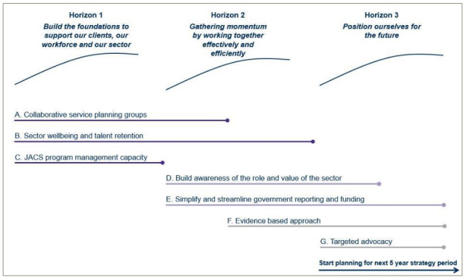

As detailed across the following pages, the Action Plan extracts each of the sector-agreed initiatives in the Strategy, and provides a dedicated implementation plan to operationalise each initiative with measurable targets, timing of activities and ownership of initiatives.
JACS and the Sector remain committed to being responsive to community needs, with the NLAP envisaging that the Strategy and Action Plan may be updated across the NLAP period, where necessary. For this reason, if there are significant changes in the Sector landscape in the Strategy and Action Plan period, the Sector and JACS will adjust its implementation planning, whilst maintaining strong alignment to the Strategy’s vision, priority outcomes and strategic directions.

ACT Legal Assistance Sector’s Strategy-on-a-page (2023–2025)
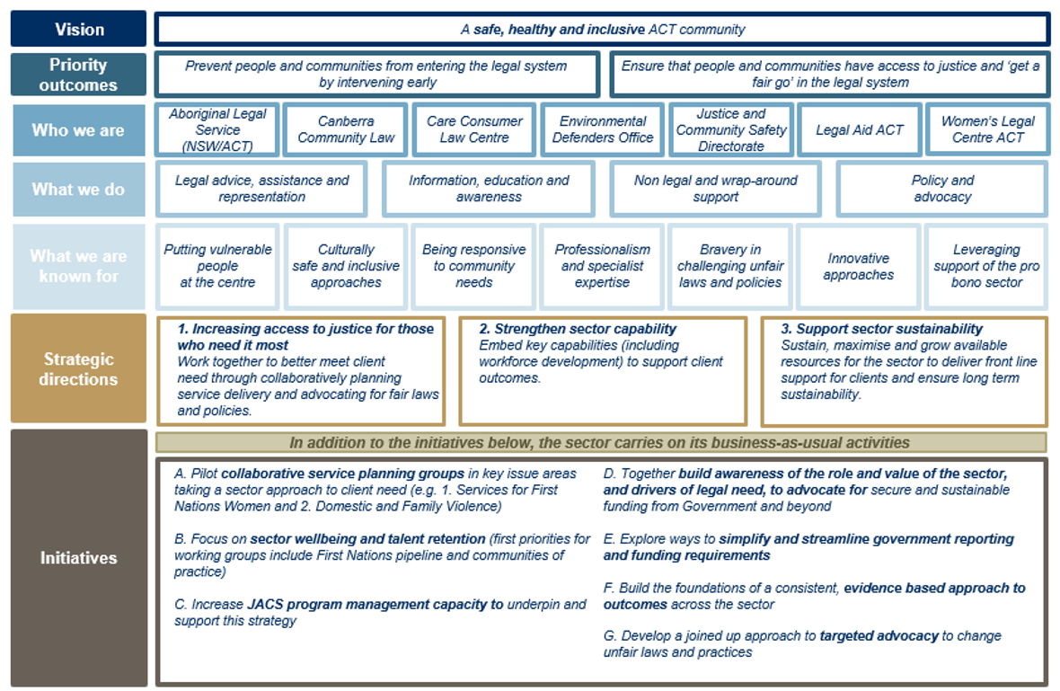
- Collaborative service planning groups
Initiative A | Pilot collaborative service planning groups in key issue areas taking a sector approach to client need
Desired outcomes and metrics for success | Initiative A commits the sector to consider piloting cross-sector collaborative service planning groups so that Partner organisations can identify potential service delivery gaps and jointly plan service delivery.
Objective | This initiative responds to the significant need identified by Partner organisations for better communication, information sharing and mutual learning across all levels of the legal assistance sector, particularly in service planning where a number of Partner organisations are providing support to similar cohorts or in similar areas of legal assistance.
Time Horizon | Horizon 1: Build the foundations to support our clients, our workforce and our sector
Strategic Direction | Strategic Direction 1: Increasing access to justice for those who need it most  Strategic Direction 2: Strengthen sector capability
Lead agency | JACS; Women’s Legal Centre, Legal Aid ACT and Aboriginal Legal Service (NSW/ACT) Limited
Who do we need to engage with? | All partner organisations; Coordinator-General for Family Safety (Community Services Directorate); ACT Law Society; ACT Bar Association and ACT Courts and Tribunal
Priority activities to support Initiative A | - JACS ACT Legal Assistance Forum (ACTLAF) members to consider including collaborative planning and decision-making into ACTLAF working sessions. Sessions can be led by working groups/taskforces to facilitate warm referrals and jointly plan responses to legal need (such as the sector’s collaboration in the creation of the Health Justice Partnership)  - Creation of two cross-sector service planning groups: Services for First Nations Women and Domestic and Family Violence.  - JACS to coordinate with Coordinator-General for Family Safety to identify work being progressed that are relevant to this initiative.
Timeframe | 2023 – JACS to reform and restructure ACTLAF to increase collaborative planning to respond to legal needs; JACS coordination with Coordinator-General for Family Safety  2023-2025 – creation of two cross-sector service planning groups
- Sector wellbeing and talent retention
Initiative B | Focus on sector wellbeing and talent retention
Desired outcomes and metrics for success | Initiative B commits the sector to taking concrete steps towards improving sector wellbeing and talent retention through the creation of a working group to tackle issues in a targeted and collaborative way.
Objective | This initiative acknowledges the difficulty Partner organisations face in attracting and retaining a diverse workforce, the need to ensure that the workforce continues to build expertise and skills, and a need to support a strong and healthy workforce to safeguard long term sustainability for the Sector and its people.
Time Horizon | Horizon 1: Build the foundations to support our clients, our workforce and our sector
Strategic Direction | Strategic Direction 2. Strengthen sector capability  Strategic Direction 3: Support sector sustainability
Lead agency | JACS; Legal Aid ACT; Aboriginal Legal Service (NSW/ACT) Limited
Who do we need to engage with? | All partner organisations; ACT Law Society and ACT Bar Association, Director of Public Prosecutions, other sector organisations who face sector sustainability challenges including Domestic Violence Crisis Service, ACT Disability, Aged and Carer Advocacy Service
Priority activities to support Initiative B | - Sector to consider development of staff satisfaction survey to inform evidence-based approach on improving wellbeing and retention  - Sector to liaise with ACT Bar Association and ACT Law Society to access professional development training  - Legal Aid ACT to administer NLAP Mental Health funding to facilitate mental health training and professional development for lawyers and support staff in the sector, available to all partner organisations and private lawyers in the sector (e.g. lawyers who work with Legal Aid or do pro bono legal work)  - JACS to coordinate development of sector approach for staff development and capacity building opportunities such as secondments between organisations.  - JACS to build staff wellbeing /development as an ongoing Service Planning Working Group (SPWG) agenda  - JACS to create virtual bulletin board accessible by partner organisations for information sharing, to foster cross-sector learning  - Sector to consider building on existing relationships with universities and industry associations to create a pipeline to recruit First Nations staff into the legal assistance sector.  - JACS to coordinate with Coordinator-General for Family Safety on work being progressed that are relevant for this initiative
Timeframe | 2023 – Sector to consider development of staff satisfaction survey, sector to liaise with ACT Bar Association and ACT Law Society for professional development, JACS to coordinate sector approach for staff development and wellbeing for SPWG; JACS to create virtual bulletin board for information sharing; JACS to coordinate with Coordinator-General for Family Safety  2023-2025 –Legal Aid ACT to administer NLAP mental health money for sector and consider access for private legal profession; creation of a pipeline for First Nations staff in the sector
- Increase JACS’ program management capacity to underpin and support the Strategy
Initiative C | Increase JACS program management capacity to underpin and support this strategy
Desired outcomes and metrics for success | Initiative C involves identifying options for JACS’ program and contract management capacity to be increased to support the efficient and effective implementation of all initiatives under this Strategy as well as support Partner organisations in their business-as-usual activities.
Objective | This initiative responds to the need for improved program and contract management, including better communication and information sharing between JACS and Partner organisations and an acknowledgement of the current constrained resourcing of JACS.  JACS to have increased capacity and capability in program and contract management to support engagement with the sector. JACS to increase sharing of information on government priorities and funding decision making processes, acknowledging the constraints on information-sharing of government decisions.
Time Horizon | Horizon 1: Build the foundations to support our clients, our workforce and our sector  Horizon 2: Gathering momentum of working together effectively and efficiently
Strategic Direction | Strategic Direction 2. Strengthen sector capability  Strategic Direction 3: Support sector sustainability
Lead agency | JACS
Who do we need to engage with? | All partner organisations; Commonwealth Attorney-General’s Department
Priority activities to support Initiative C | - JACS to review information-sharing on government priorities to the sector to support the sector in driving initiatives and programs that align with achieving the initiatives of the Strategy and Action Plan.  - JACS to explore opportunities to develop a legal assistance program management model, and upskill JACS staff in program management  - Sector to consider model for short term secondments between service providers and government
Timeframe | 2023 – JACS to explore opportunities for increased program and contract management capacity and upskilling; JACS to increase information sharing on funding decision-making processes  2023-25 – JACS to increase transparency around resourcing to support the sector to achieve the Strategy and Action Plan; Sector to consider short term secondments
- Build awareness of role and value of Sector
Initiative D | Together build awareness of the role and value of the Sector, to advocate for secure and sustainable funding from Government and beyond
Desired outcomes and metrics for success | Initiative D will explore opportunities to raise awareness and build understanding across all areas of government about the role of the Sector, the value of its work and how legal assistance issues intersect with other social issues. It involves a joined-up approach across the Sector, with JACS and the Attorney-General playing a critical role.
Objective | This initiative responds to issues identified by partner organisations, including that government needs to better understand the drivers of legal need and how decisions in one area of government can have a significant effect on legal need and demand for services. It also acknowledges that securing sustainable funding is an ongoing challenge and increased understanding of the Sector may result in increased sustainable funding from government and, potentially, philanthropy.
Time Horizon | Horizon 2: Gathering momentum of working together effectively and efficiently  Horizon 3: Position ourselves for the future
Strategic Direction | Strategic Direction 2. Strengthen sector capability  Strategic Direction 3: Support sector sustainability
Lead agency | JACS
Who do we need to engage with? | All partner organisations; ACT Attorney-General; Commonwealth Attorney-General’s Department
Priority activities to support Initiative D | - JACS to develop a clear whole of sector funding and programs profile to better present investment  - JACS to increase consultations with the broader justice sector organisations at early stages of developing funding proposals  - JACS to consider and review current funding processes that may be competitive and discourage collaboration  - JACS to work with the partner organisations to support them to pursue longer-term funding arrangements with the ACT Government and Commonwealth Governments  - Establish, through ACTLAF, collaborative funding opportunities for partner organisations to review and pitch for funding where interests align.  - JACS to coordinate with Coordinator-General for Family Safety on work being progressed that are relevant for this initiative
Timeframe | 2023 – JACS to coordinate with Coordinator-General for Family Safety  2023-2025 – JACS to review current competitive funding processes; JACS to support partner organisations to seek secure and sustainable funding from ACT and Commonwealth Government; Create collaborative funding opportunities through ACTLAF.

- Simplify and streamline government reporting and funding requirements
Initiative E | Explore ways to simplify and streamline government reporting & funding requirements
Desired outcomes and metrics for success | Initiative E will explore opportunities to simplify and streamline government funding and reporting requirements to reduce the complexity and resourcing required for government reporting, freeing up the capacity of the Sector to deliver its front-line services and deliver on this Strategy.
Objective | This initiative responds to the challenges identified by Partner organisations associated with the capacity and resourcing required to meet contractual reporting obligations for funding contracts.
Time Horizon | Horizon 2: Gathering momentum of working together effectively and efficiently  Horizon 3: Position ourselves for the future
Strategic Direction | Strategic Direction 2. Strengthen sector capability  Strategic Direction 3: Support sector sustainability
Lead agency | JACS
Who do we need to engage with? | All ACT Government agencies that have a funding relationship with the legal assistance sector; Commonwealth Attorney-General’s Department
Priority activities to support Initiative E | - JACS to consolidate/streamline the number of funding agreements partner organisations need to manage and report on – for example, consider 12-monthly reporting periods rather than 6-monthly  - JACS to align ACT and Commonwealth Government reporting cycles in new or varied funding agreements  - JACS to coordinate with ACT Treasury on demand driven funding models to deliver funding to justice sector agencies  - Sector to discuss around the future and use of Statutory Interest Account funding  - JACS to coordinate with CSD and the Coordinator-General for Family Safety on work being progressed that are relevant for this initiative
Timeframe | 2023 – JACS to streamline the number of funding agreements with partner organisations; JACS to align ACT and Commonwealth reporting cycles; JACS to coordinate with Coordinator-General for Family Safety

- Build evidence-based approach to outcomes
Initiative F | Build the foundations of a consistent, evidence-based approach to outcomes across the sector
Desired outcomes and metrics for success | Initiative F is the first step for the Sector to move to a consistent, evidence-based approach to outcomes management so that, over time, the Sector better understands its progress towards achieving outcomes for clients and the community and can use outcomes data to inform its service delivery and other key activities.
Objective | It is acknowledged that this is a long-term aspiration and that activities within this initiative focus on setting the foundations and priority activities under this initiative may include mapping the existing outcomes data which is being captured across the Sector as well as exploring opportunities to improve current processes for reporting and data collection.
Time Horizon | Horizon 2: Gathering momentum of working together effectively and efficiently  Horizon 3: Position ourselves for the future
Strategic Direction | Strategic Direction 1: Increasing access to justice for those who need it most  Strategic Direction 2. Strengthen sector capability
Lead agency | JACS
Who do we need to engage with? | Commonwealth Attorney-General’s Department
Priority activities to support Initiative F | - JACS to build into ACT Government reporting requirements, how service delivery outcomes are meeting sector-agreed initiatives and strategic directions to align with the Strategy and Action Plan  - Through ACTLAF, develop consistent and aligned approach to outcomes across the sector to support a focus on client impact, minimise duplication and ensure sector strengths are leveraged  - Sector to identify funds to invest into the capacity of sector providers to collect data and support collaborative models  - JACS to advocate to Commonwealth Government on client outcomes and metrics to be used as assessment criteria and performance indicators under intergovernmental agreements  - Consider qualitative methods to ensure data reflects complexity of work and is not solely focused on client numbers
Timeframe | 2023-2025 – develop consistent outcomes approach that focuses on client impact; JACS to advocate to Commonwealth Government on client outcomes and metrics; consider qualitative methods that reflects complexity of work
- Joined-up approach to target advocacy
Initiative G | Develop a joined-up approach to targeted advocacy to change unfair laws and practices
Desired outcomes and metrics for success | Initiative G involves a collaborative approach for the Sector to work on targeted advocacy issues, leveraging the skills and expertise of the Partner organisations to challenge unfair laws and practices in a unified way.
Objective | This initiative acknowledges that Partner organisations are resource constrained in carrying out advocacy and do not currently engage in advocacy as a Sector (where it is appropriate to do so).
Time Horizon | Horizon 2: Gathering momentum of working together effectively and efficiently  Horizon 3: Position ourselves for the future
Strategic Direction | Strategic Direction 1: Increasing access to justice for those who need it most  Strategic Direction 2. Strengthen sector capability  Strategic Direction 3: Support sector sustainability
Lead agency | JACS
Who else will we engage with? | All partner organisations; ACT Government agencies in relation to specific advocacy issues
Priority activities to support Initiative G | - Through ACTLAF, service providers establish key law reform working groups (e.g. housing or care and protection), and provide the sector’s position to ACT Government  - JACS to explore opportunities across existing platforms, to establish an ACTLAF bulletin board to share information across the sector, develop a knowledge base for legislative reform and other issues, and identify dedicated resourcing opportunities  - JACS to continue to coordinate sector collaboration beyond service delivery on law reform and advocacy opportunities
Timeframe | 2023 – JACS to establish ACTLAF bulletin board as a knowledge base for legislative reform and other issues  2023-2025 – JACS to coordinate sector collaboration on law reform and advocacy opportunities

Australian Capital Territory, Canberra 2022.
The ACT Government acknowledges the Ngunnawal people, the Traditional Custodians of the lands on which the ACT legal assistance sector operates. We pay our respects to Ngunnawal Elders past, present and emerging. We recognise the continuing culture and connection to the country of the Ngunnawal people, and of Aboriginal and Torres Strait Islander peoples across Australia, and the contribution they make to the life of the city and region.

